Calculus 3 Lecture 12.3: Arc Length/Parameterization, TNB (Frenet-Serret) Intro

Arc Length from Parametric Equations
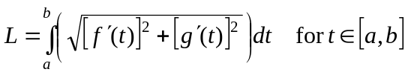

Arc Length for 3-d:
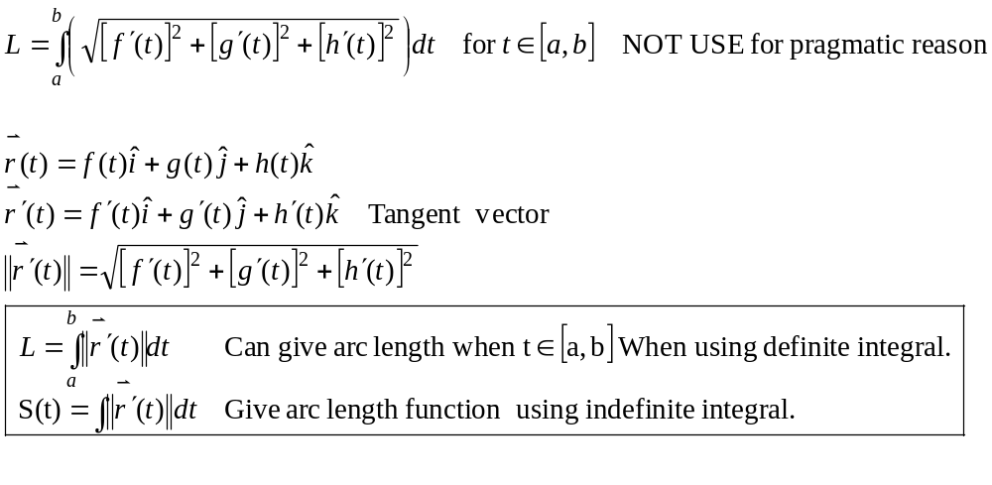

Example
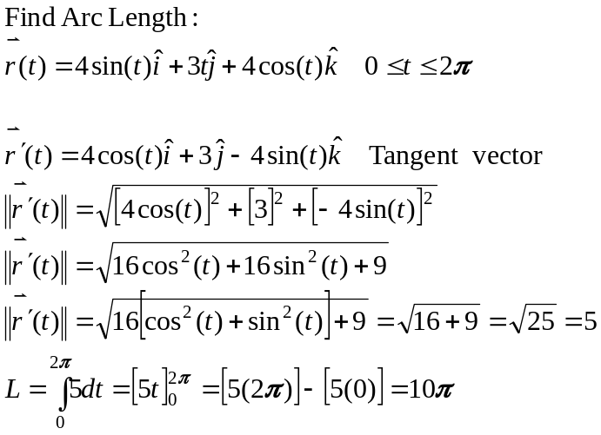

Example
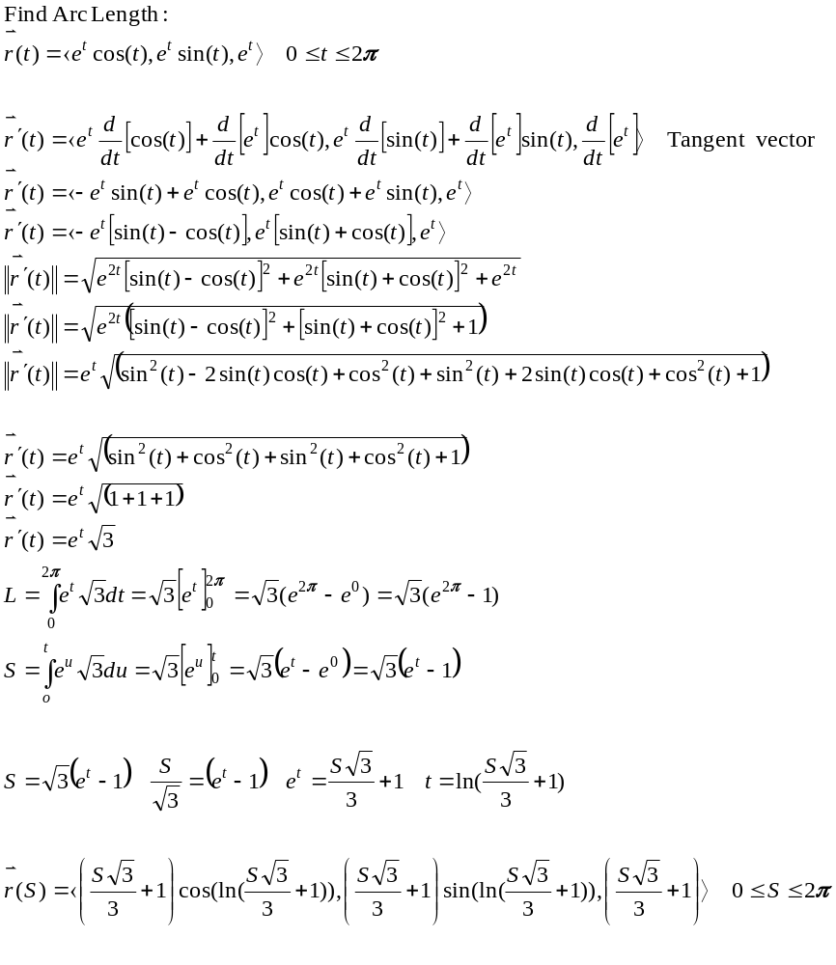

For “smooth curves” we can re-parameterize by Arc-length….Why?
- We can “walk the curve”.
- Some formulas are easier
- 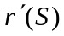 will always have a magnitude of 1 (unit tangent vector)

Example
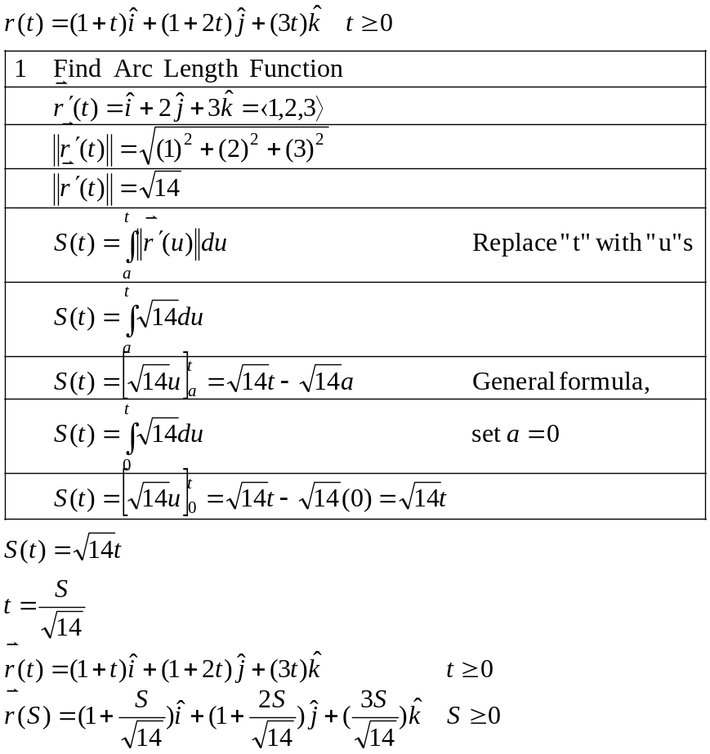

Example
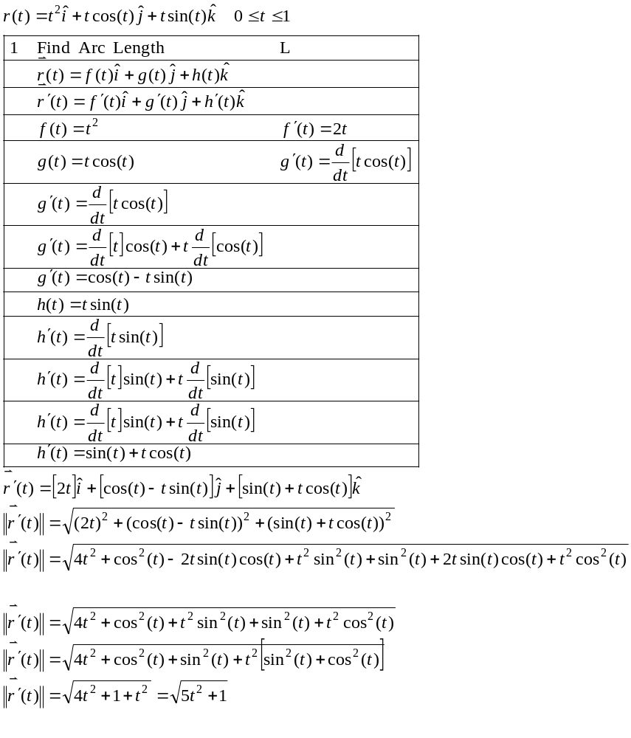
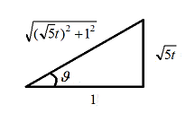
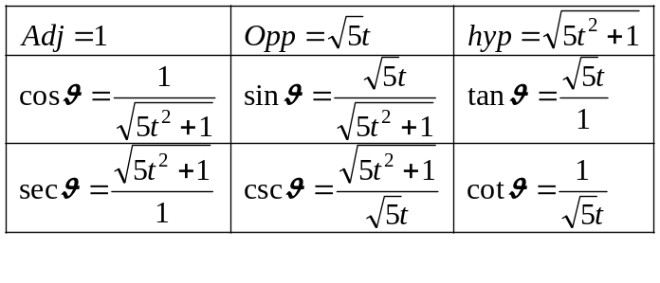
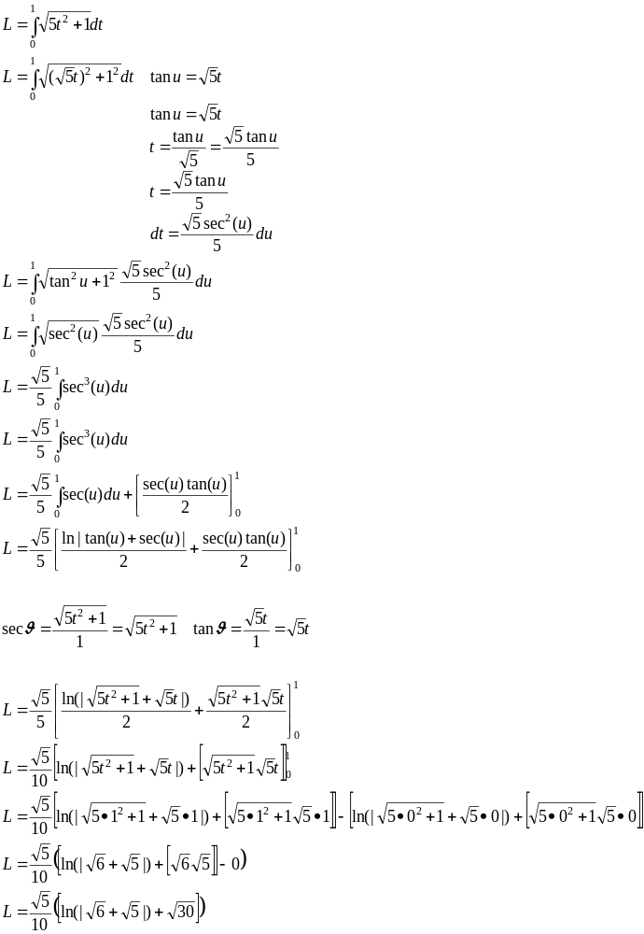

TNB Frames (Frenet-Serret Frames)
At every point, the TNB frame gives us the Unit Vectors…
- T “” is the unit vector tangent to the curve, pointing in the direction of motion.

- N “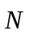” is the normal unit vector, the derivative of T with respect to the arclength parameter of the curve, divided by its length.

- B “”is the binormal unit vector, the cross product of T and N.

These vectors are Mutually Orthogonal to each other (they make a moving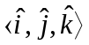Vector. Looks like an Moving (x,y,z) axis.

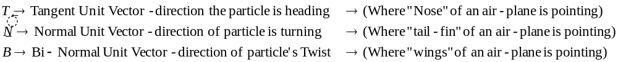

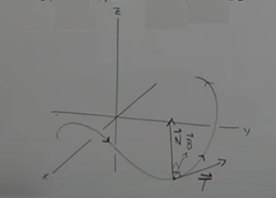

How to TNB:
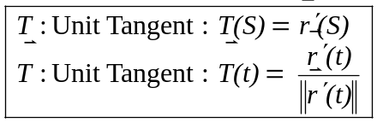
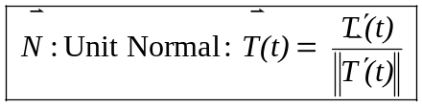 A unit vector that is 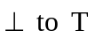
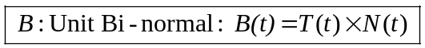

* Every vector with a Constant Length is perpendicular to its Tangent Vector

PROOF:
Let have a constant length
